A Lost Son
Object Lesson 4

Scripture: “For The Son Of Man Is Come To Seek And To Save That Which Is Lost.” Luke 19:10

Objective: To illustrate that we influence others around us.

Materials Needed: 2 bottles the same size, 6’ of light weight electrical wire, a 3’’dowel, and 2 metal chairs.

Set Up: Attach rods between 2 metal chairs, fill both bottles with water to the same level and attach both bottles with electrical wire the same distance form the ends of the rod.

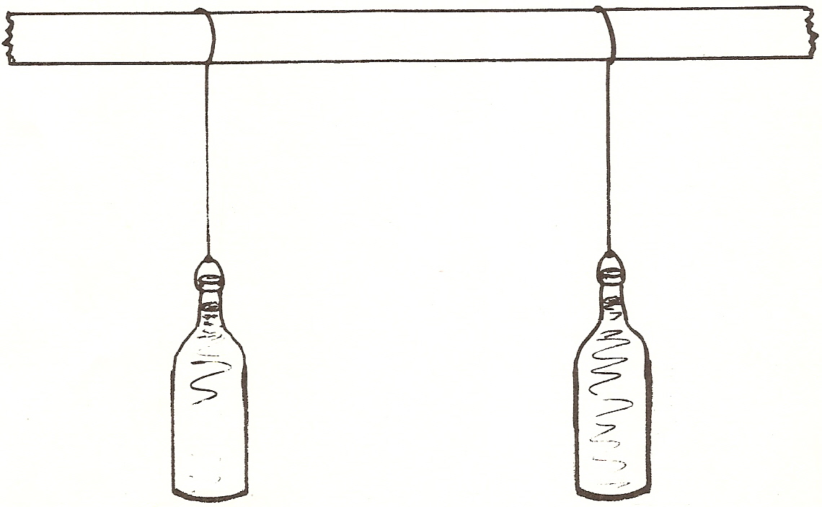
What to Do:
Boys and girls in your life time you will influence 11 people. Will you be influencing them for Jesus? Are will you be influencing them for the devil.

This morning I have 2 bottles hanging from this rod. Let’s say I want to make the bottle on the right swing. How can I do this I could just push it and make it move, right? But let’s say that instead I want it start to move on it own. I am willing to influence it and encourage it any way I can but I don’t want to touch it. (Now push the left bottle and make it swing as it begins to stop the right bottle begins to pick up and move.) As you can see I never touched the bottle on the right it just began swinging on its own you say. No, you see the first bottle that I did start swinging created such movement through friction through the rod into the other end that it forced it to move even thought I never touched it. Even though we might never touch the lives of other people physically, we are influencing them every day of our lives that we are around them. In which direction are you influencing people? Statistics tell us that we influence 11 people in our life time to do what we are doing. If that is true, what are the 11 people that you are going to influence going to be like? That is something only you can answer and you will also have to answer to God. God wants you to influence people for Him by the way you live your life and cause them to want to be a Christian too.

